**e-Yantra Ideas Competition - 2020**

**Title: Amphibious Autonomous Surveillance UGV**

# Abstract:

The aim of this project is to propose an architecture for an intelligent surveillance system. The aim is to lessen the burden on humans due to conventional surveillance systems by incorporating intelligent framework, computer vision in co-operation with autonomous mobile robots (UGV’s). We tackle the problem of robot surveillance decision and how the integration of various components in the system support fully-automated decision making.

We present a modern approach for surveillance at remote and border areas, multi-storey buildings, manufacturing facilities and natural resource extraction plants, and other such institution that encompass a large area. This robot is also useful for home security where it could act like a companion of some sort to the individual. Its amphibious nature allows it to traverse on terrains such as sand, mud, snow and water with ease without hindering its functionality.

It is a multifunctional robot based on IOT aspects. This UGV possess the ability to assist a solider at border area or a guard at various facilities lessening their burden and providing tight security even at home. This robot has multiple sensors that detect the presence of enemy capture it in camera and give the live video and audio to the authorized person. Detect smoke, footsteps, IED’s and transmit its location to the control centre.

# Introduction/Motivation:

With recent research development in computer vision, robot autonomy has the potential to revolutionize surveillance technology. Take into account the manpower and concentration spent by security personnel to monitor numerous live video feeds from cameras that are presently surveilling parking lots, university campuses and shopping malls. Imagine the dexterous patrols of security guards through countless corridors. Think over the difﬁcult strategic decisions about where and how to allocate precious human resources, corresponding to immediate security issues and in anticipation of the future ones to come.

Robot mobility has advanced to the level where robots now have the ability of navigating complex environments, patrolling as humans would do. Equipped with cameras and other sensors they can serve as mobile surveillance node. For example, a robot can provide coverage to areas that may be critical due to camera failures or other such factors. Robots also have the mobility, sensors, and actuators to react directly to a situation detected over a camera feed, thereby leveraging real-time scene analysis. To integrate these technologies effectively, and to make robots truly autonomous, a third key technology: intelligent decision making. Here robots choose their actions so as to accomplish a combination of objectives given constrained resources.

This project resolves the problem of replacing humans to surveillance robots by finding a bridge between the two. We reduce harm of human resources. The Robot is miniature in size capable enough to enter tunnels, mines and holes in building and also have capability to survive in harsh and difficult climatic conditions for a feasible amount of time.

To maintain safety and security conventional surveillance systems rely critically on human attention, action and intelligence. However, such reliance is less productive in a society where the trend is for more cameras, embedded systems and complex surveillance environments, to fend against potential threats (from burglary, to natural disasters, to terrorist attacks). We emphasise the need to a shift onto autonomous systems, in order to meet present-day surveillance demands and needs.

# Literature Survey/Prior Artwork:

Systems have already been developed to autonomously analyse video feed in environments such as transportation networks and public spaces, to identify actors and characterize behaviours. Example IBM’s Smart Surveillance System project and Yao et al.’s system for cooperative object tracking. There are also approaches for activity interpretation, while other works are focused on low-bandwidth requirements by locally processing surveillance images. A four wheeled robot for Surveillance in Military Applications. Mobile Robotic System for Surveillance of Indoor Environments robot can be used to interact with the environment, with humans or with other robots for more complex cooperative actions have also been developed.

The research gap of the project compared to the previous versions:

* Cost reduction in cost by making the design with reference to spherical robots and integrating them with the conventional two-wheeled self-balancing robot model.
* It builds on top of a partially existing idea and brings together the best of things to be used in a sector that is different from the conventional one.
* The mechanical design is brought down to a level where it can be reproduced easily with the help of additive manufacturing and is given a robust structure that can absorb and adapt to situations.
* A two-wheeled unconventional robot of original make by taking inspiration from the already existing wheeled robots and try to accommodate as many features as possible if not more as provided by the other robots.
* The robot can perform up to its maximum capability despite the changes in environment (such as sand, staircase, mud etc.) and also incorporate the ability of indoor wall climbing.
* We try to make the robot suitable for home security where it might act as companion of sort.

# Problem Statement:

Design and development of a robust Two-Wheel Amphibious Autonomous Surveillance Robot (UGV-Unmanned Ground Vehicle) in integration with multi-agent surveillance framework as a better alternative to the conventional surveillance system for patrolling facilities and border patrol. We increase the efficiency of the traditional system and lessen the burden on human resources.

## Hardware requirements:

## Software requirements:

* OS
* MATLAB
* ROS
* Python

## Mechanical Aspects:

The robot consist of a two wheel self-balancing robot. Due to the unique structure and material of the wheels the robot can accommodate itself on rough terrain and climb stair by balancing its centre of gravity. The wheels also absorb any impact that occur due to the robot falling from a height making it a robust system. The robot possess suction cups that give the robot the ability to traverse on walls that are indoors. The wheel design is such that the robot can traverse on surfaces such as sand, snow and also float on water. It consist of four BLDC motors that form a combination to give a planetary gearhead reduction.

The distinguishing feature is the comparatively small make of the robot that helps it interact with the environment better.

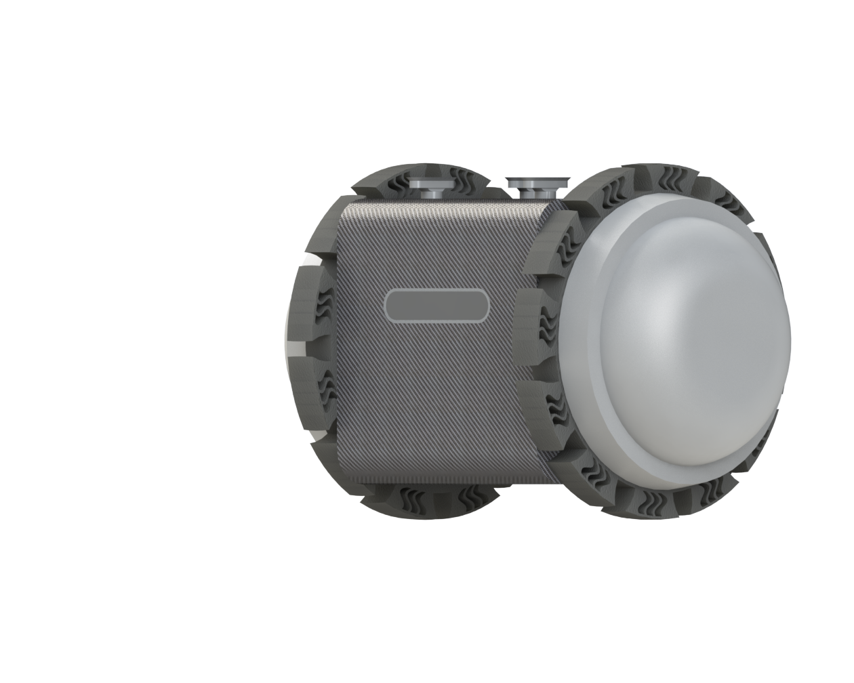

# Implementation:

* Intel RealSense camera is used to localize the robot using monocular visual odometry (position of the robot i.e. rotation and translation in 2D space). For accurate measurement of these values an Inertial Measurement Unit (IMU). Cameras at the rear alternate source for monocular visual odometry as well as make the system reliable and robust.
* Lidar rangefinder is used for mapping of the environment for more precise localisation information of the robot. Kalman filter with sensor fusion is used for accurate measurements and also used different types of filtering techniques on sensors raw measurements. Particle filter is used for localisation in known environments.
* GPS is used for location tracking.
* YOLO algorithm is used for detection of suspicious objects or individuals (e.g.: detecting guns, terrorists, etc.).
* 4G modem/dongle is used to transmit feed data i.e. video/audio as we as link the robot with other patrol robots in the framework.
* 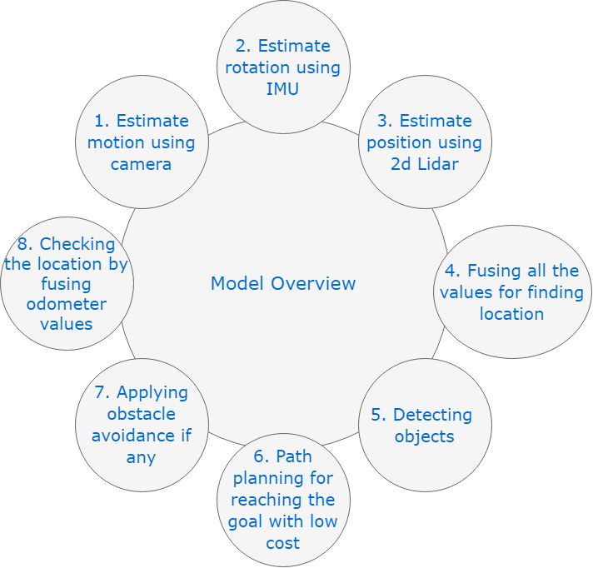The control of the robot is done using LQR Feedback controller by using various sensors like IMU, Camera, and Lidar.

# Flowchart:

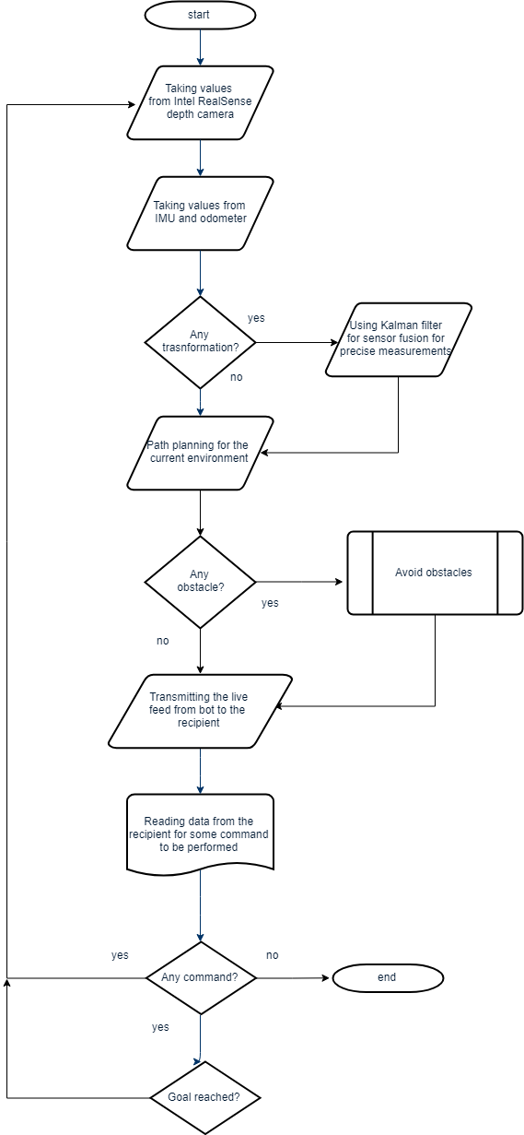

# Features:

Features we plan to implement:

* Obstacle Avoidance -Automatically detect and avoid Obstacles.
* Real-Time Threat Assessment
* Real-Time location tracking
* Real-Time video/audio surveillance
* Smoke /Fire detection
* Movement/Noise detection
* Auto Pilot
* Two-wheeled robot Staircase Climbing
* Two-wheeled robot Indoor Wall Climbing
* 4G connectivity for sending commands
* Robust structure that can absorb impact when falling from a height

# Feasibility:

The value and the selling point of our device will be the unique design, autonomous locomotion and its amphibious ability. It will be used by many surveillance companies. Its main advantage is that it will go unnoticed during the surveillance and also will be giving live data feed seen by the robot to the control centre. This device does not replace the human resource but rather aids their functioning thereby increasing the efficiency and lessening the burden put on them. This robot will integrate with already available systems present at the institution thus proving very cost effective. Mobility of the bot is feasible for a wide number of traversing regions, for example it can climb on the stairs or walls which proves very helpful in multi-storey building surveillance. It has also ability to stick to the ceiling of the room and asses the threat without being noticed and act as a mobile camera of sort.

# References:

1. Joshi, S. A., Tondarkar, A., Solanke, K., & Jagtap, R. (2018). Surveillance Robot for Military Application. International Journal of Engineering and Computer Science, 7(05), 23939-23944. Retrieved from http://www.ijecs.in/index.php/ijecs/article/view/4066
2. Di Paola, D., Milella, A., Cicirelli, G., & Distante, A. (2010). An Autonomous Mobile Robotic System for Surveillance of Indoor Environments. International Journal of Advanced Robotic Systems. <https://doi.org/10.5772/7254>
3. Del Corte, A.; Gutierrez, O.; and Gomez, J. 2012. New location techniques based on ray-tracing for increasing airport safety in a pronandstand areas. Frontiers in Computer Education: Advances in Intelligent and Soft Computing133:515–522.
4. Schmidt D., Berns K.; climbing robots for maintenance and inspections of vertical structures - A survey of design aspects and technologies: Robotics and Autonomous Systems, Volume 61, 2013.
5. Cucchiara,R.;Grana,C.;Prati,A.;Tardini,G.;and Vezzani, R. 2004. Using computer vision techniques for dangerous situation detection in domestic applications. In Intelligent Distributed Surveillance Systems, IEE,1–5.